**Security Groups:**

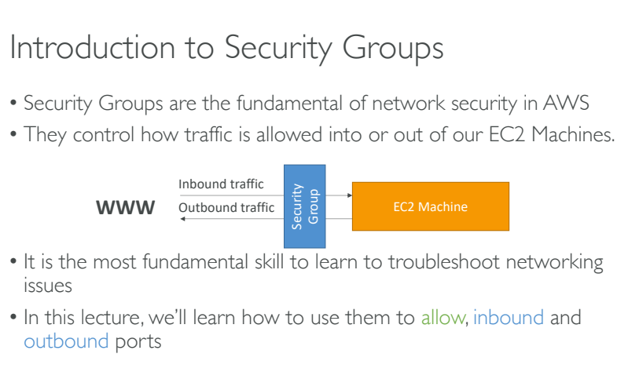

1. Security groups mainly deal with accessibility and which protocols to accept while or after creating an EC2 instance.
2. Its not about users its about protocols.
3. The main task in ‘security groups’ is to check and provide which protocols like TCP, SSH or HTTP to the EC2 instance.
4. Go to EC2 instance and then select ‘Security Groups’.
5. We can create a new security group and can attach to the running instance.
6. An ‘Inbound’ rule explains about the type of services that are allowed to access the instance.
7. An ‘Outbound’ rule explains the type of services that an instance can allow.
8. By default an inbound rule is applied as Outbound rule.

NOTE: By default we cannot disable a specific ip or specific protocols.

